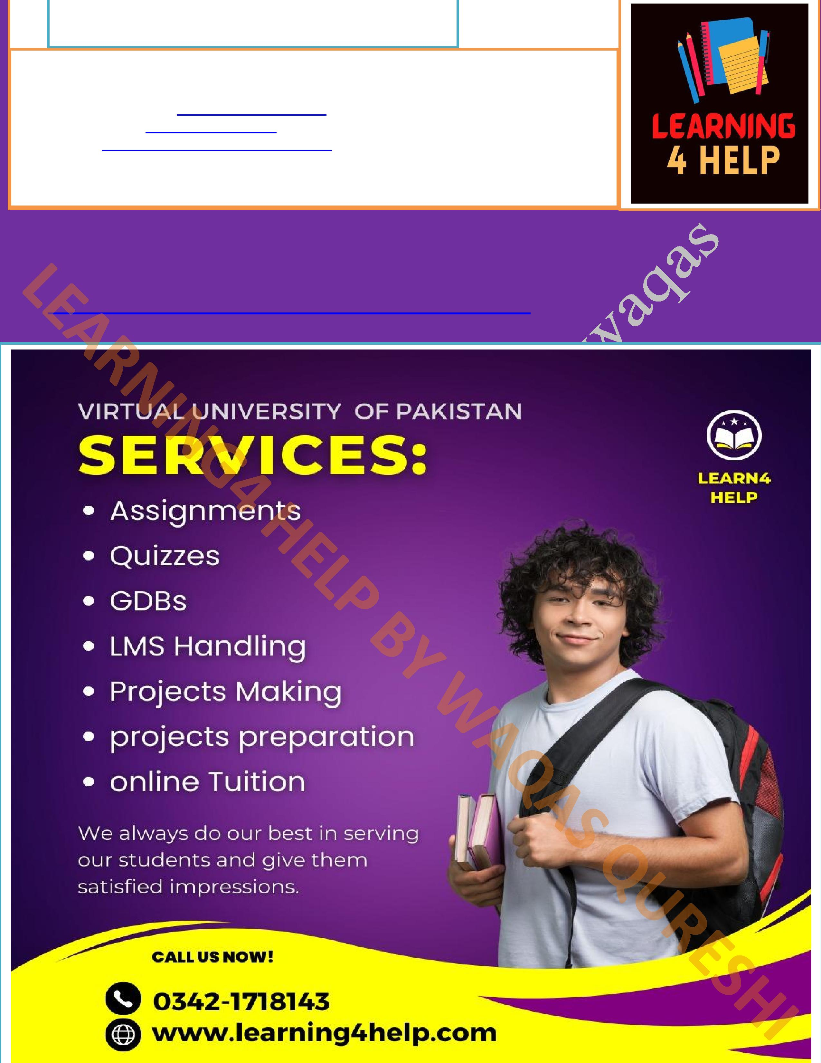
Learning4help by Waqas
Asslam-o-Alaikum! In this file we’ll provide you PAK301 quiz 4 2023 Important Finalterm MCQs. Must Prepare Before Finalterm Exams. Verify Answers yourself too. If you found mistake then inform me.
If you found mistake then let us know.
You can contact us on WhatsApp https://wa.me/+923421718143 Or You can send us gmail: Learningn4help@gmail.com
Facebook page is https://m.facebook.com/WAQASQURESHI34555/ For more educational stuff keep visiting
https://learning4help.com
Subscribe to my Channel: https://www.youtube.com/channel/UCCGywvKgSGACQHPuq-951Q

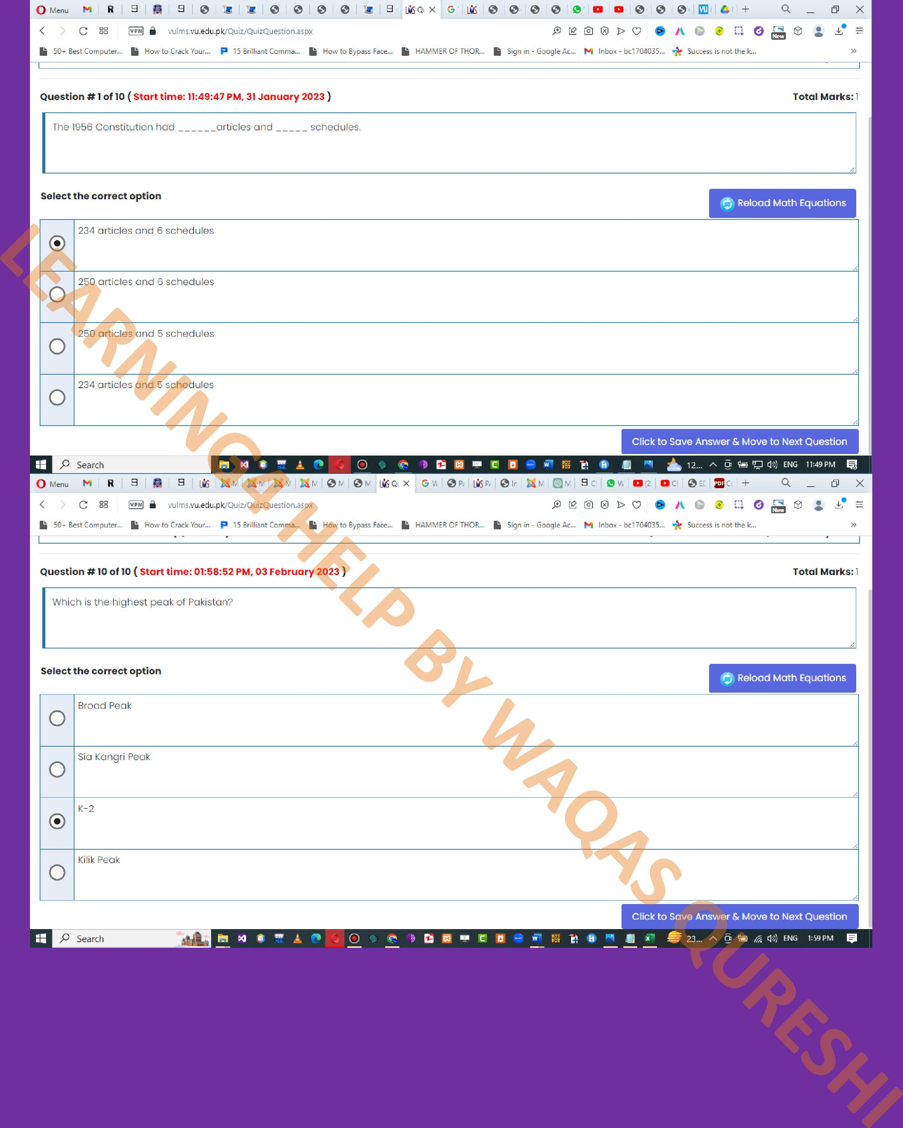
2

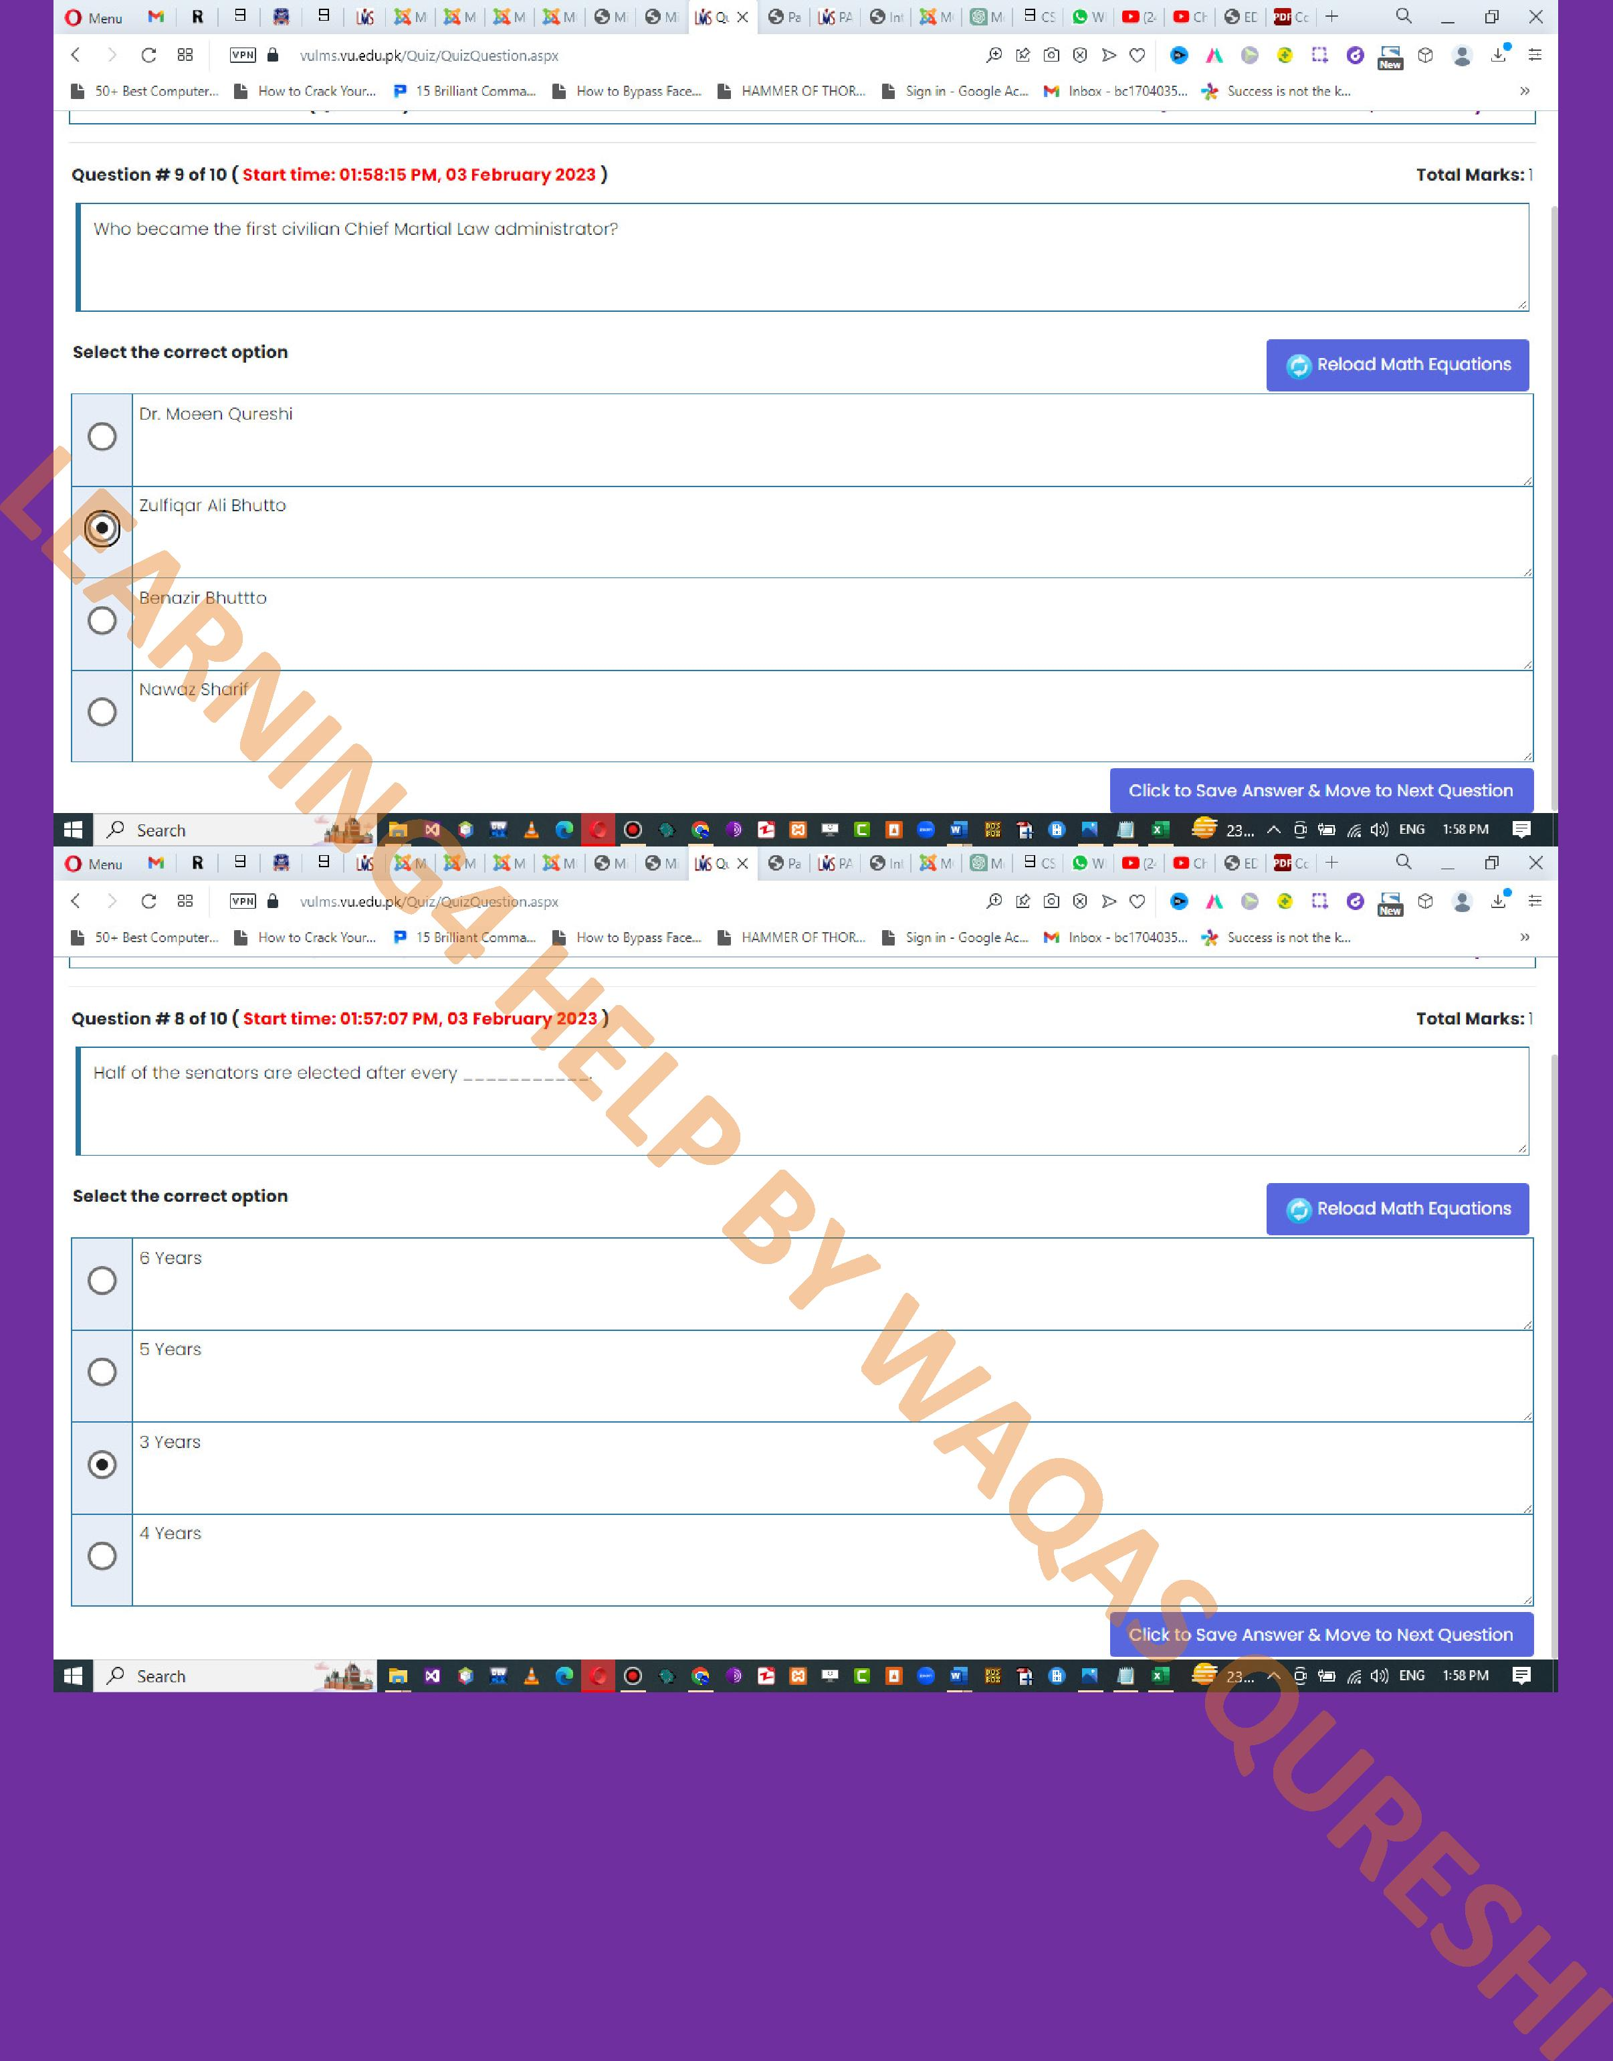
3

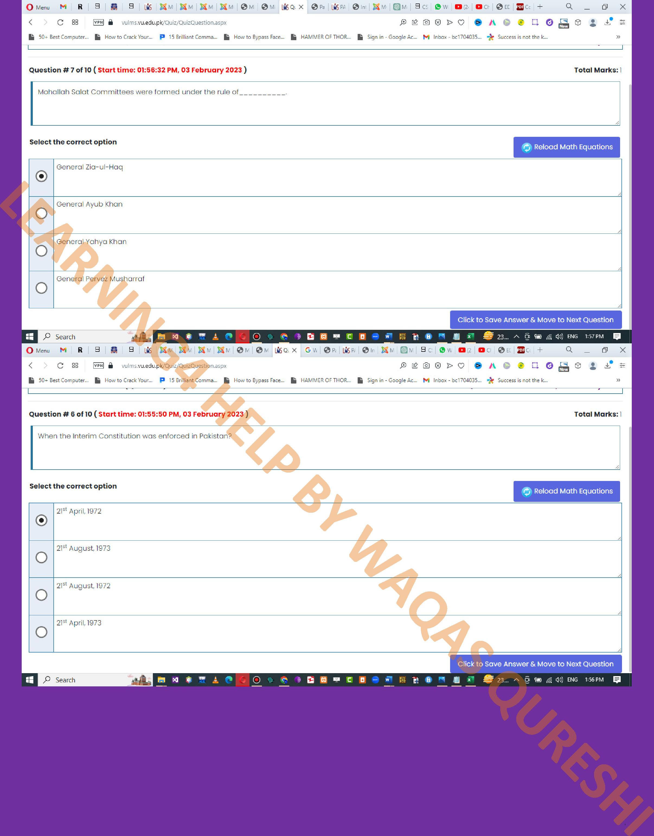
4

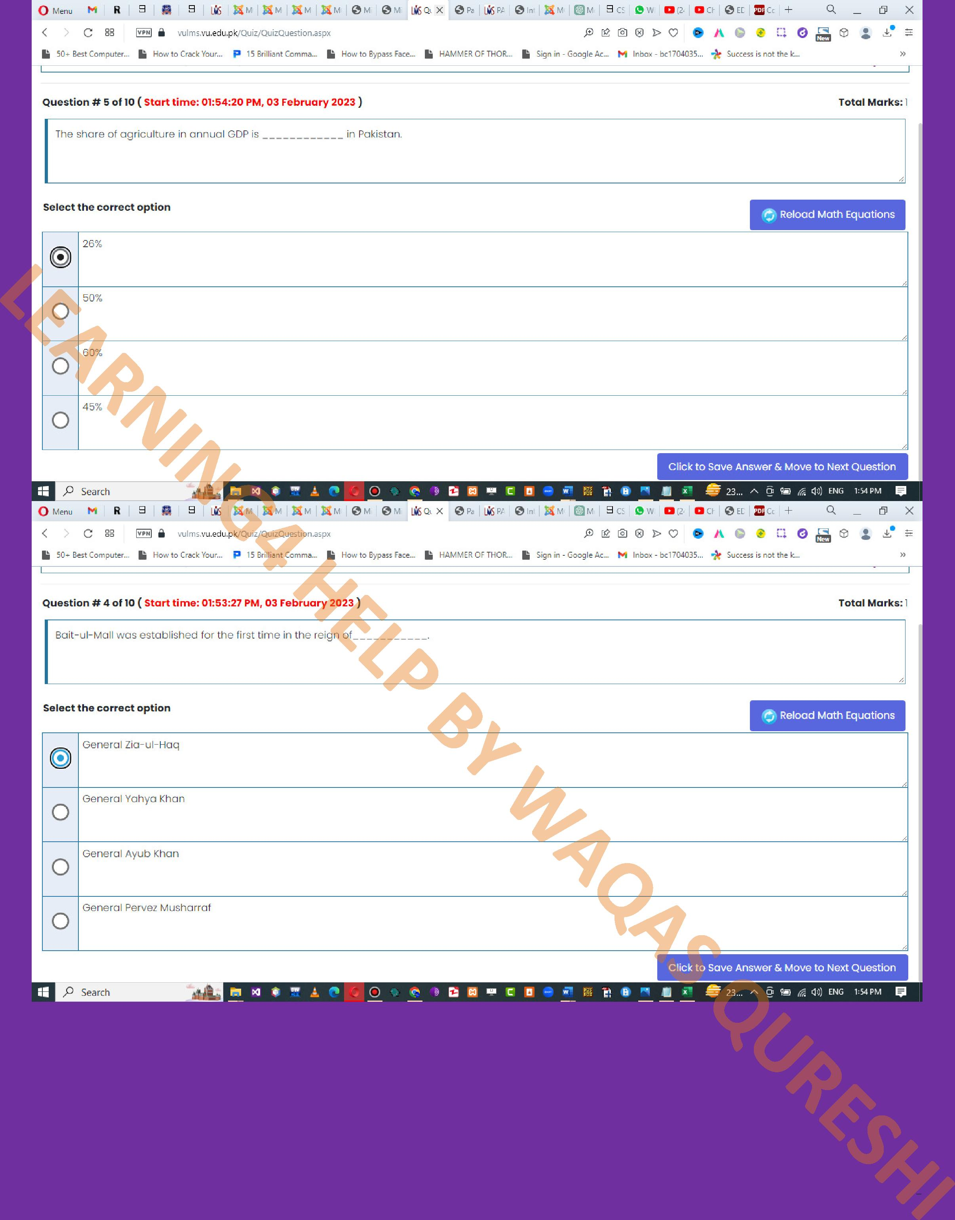
5

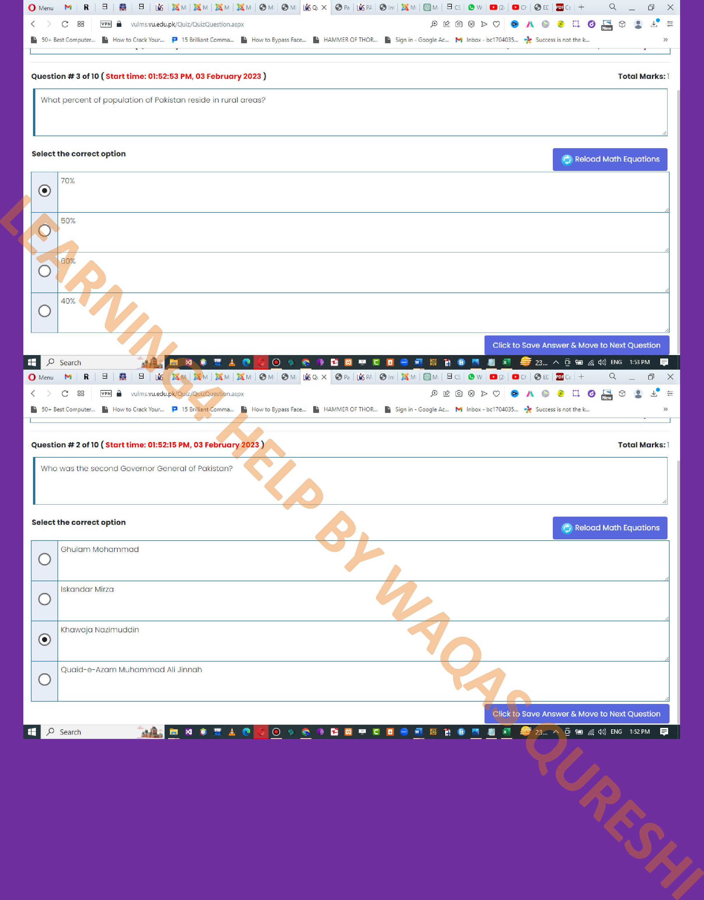
6

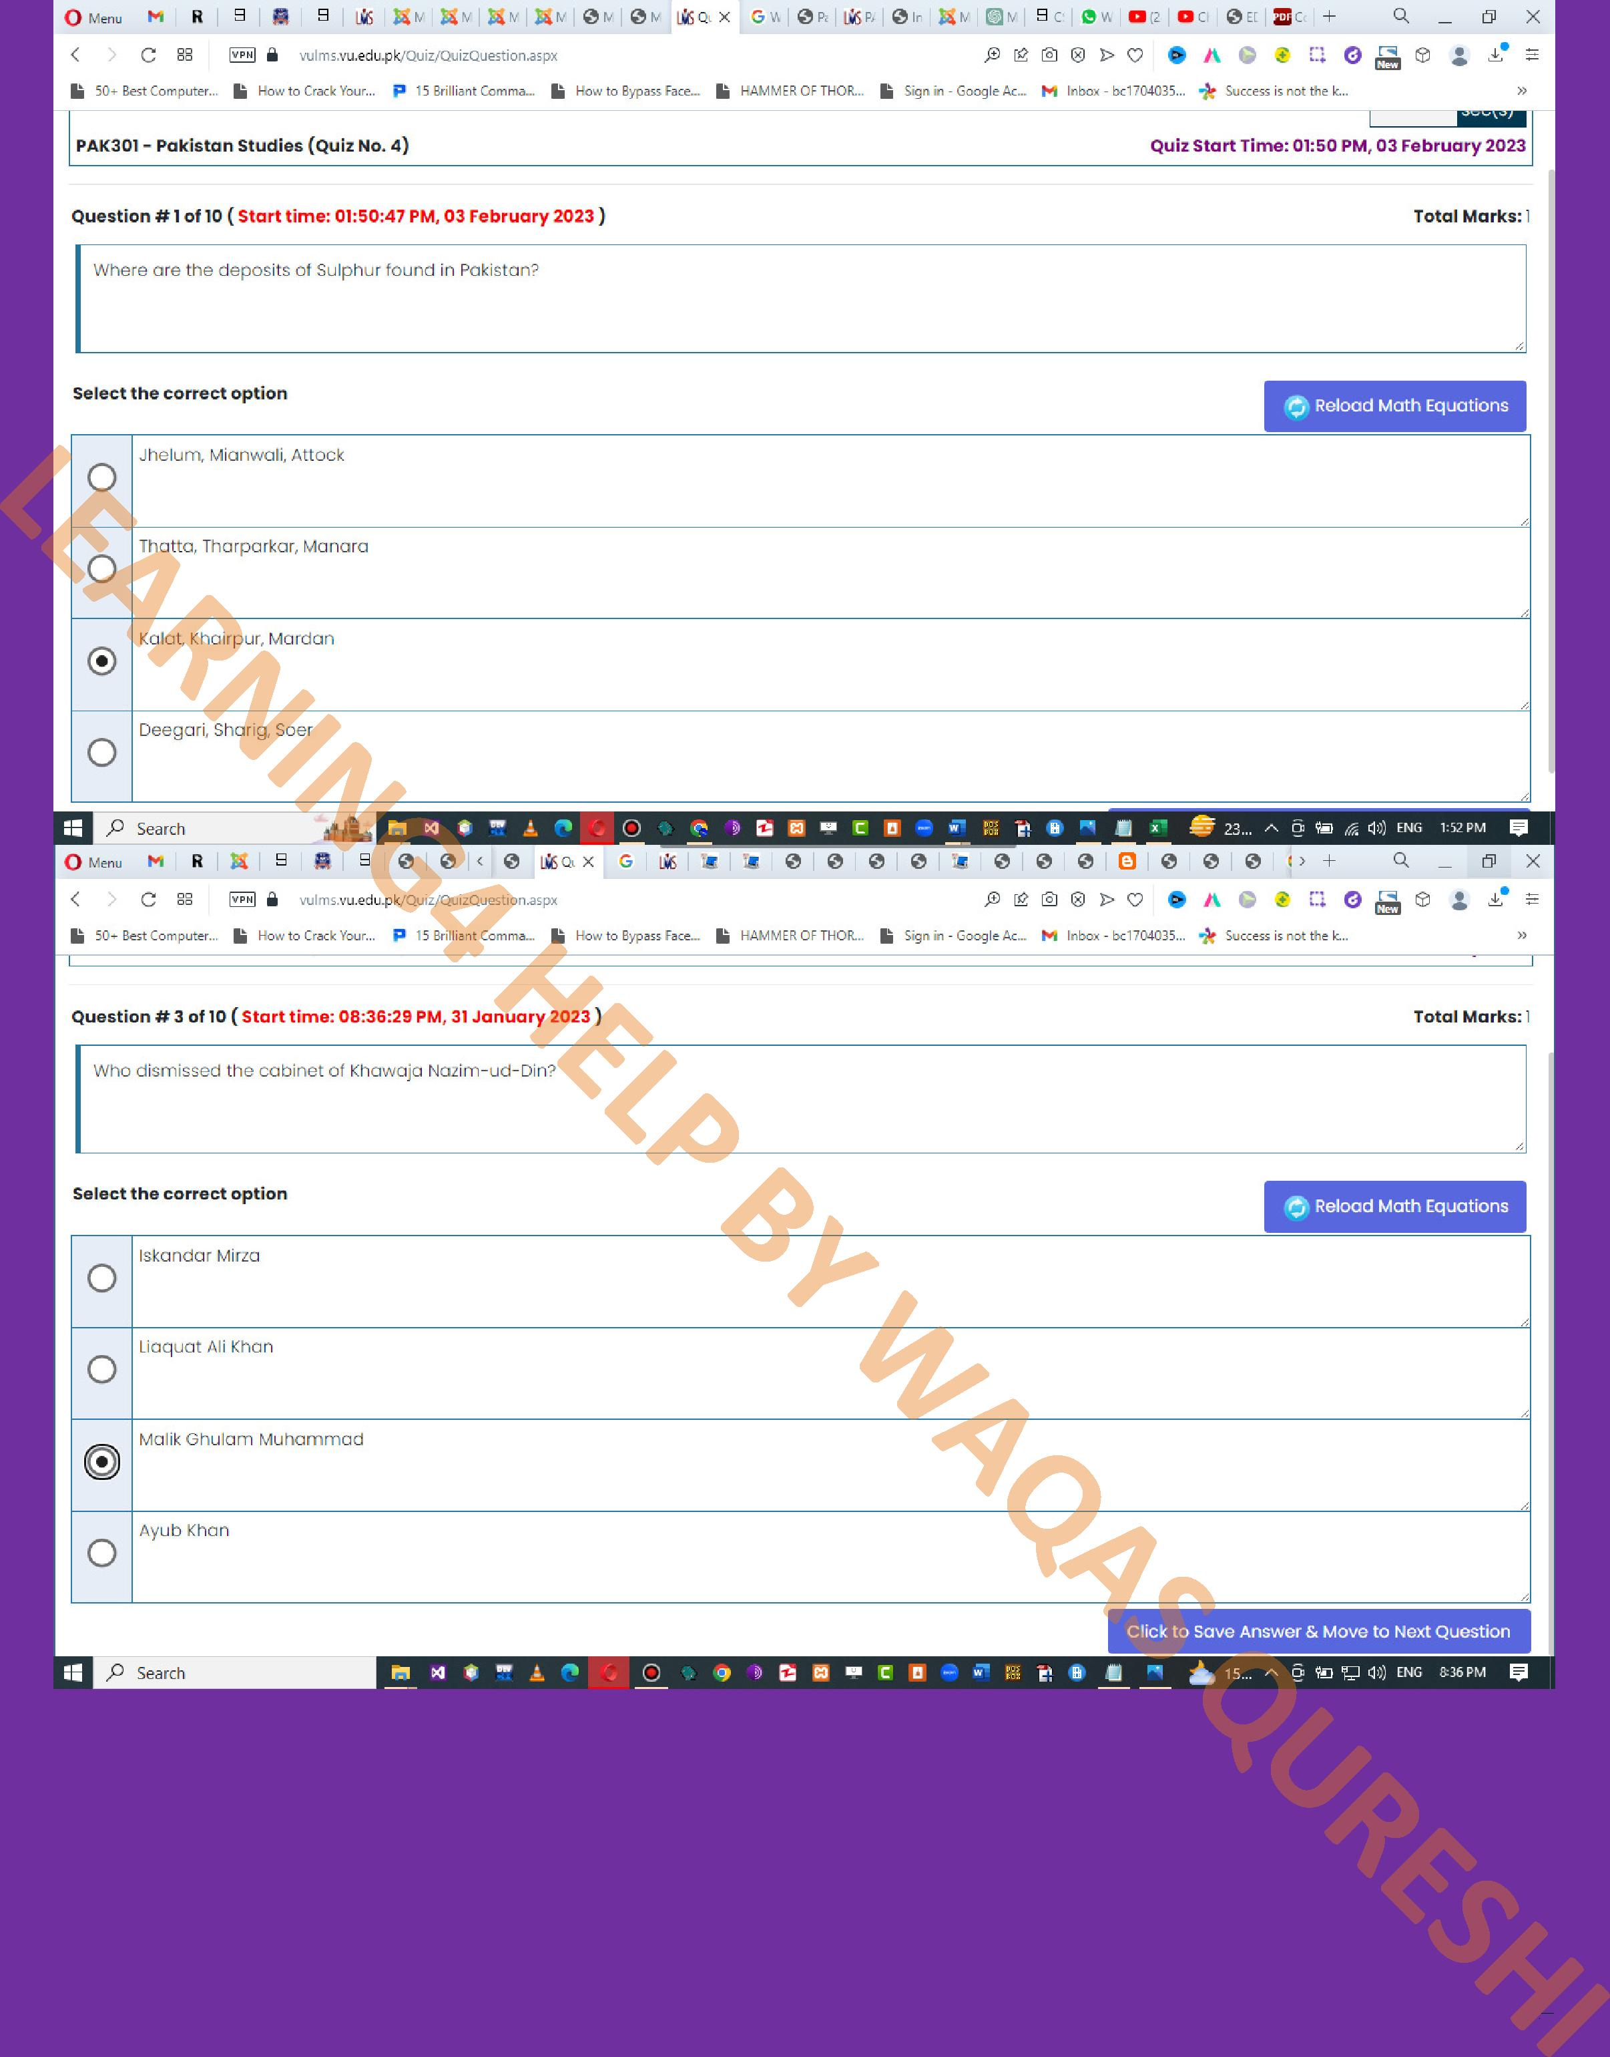
7

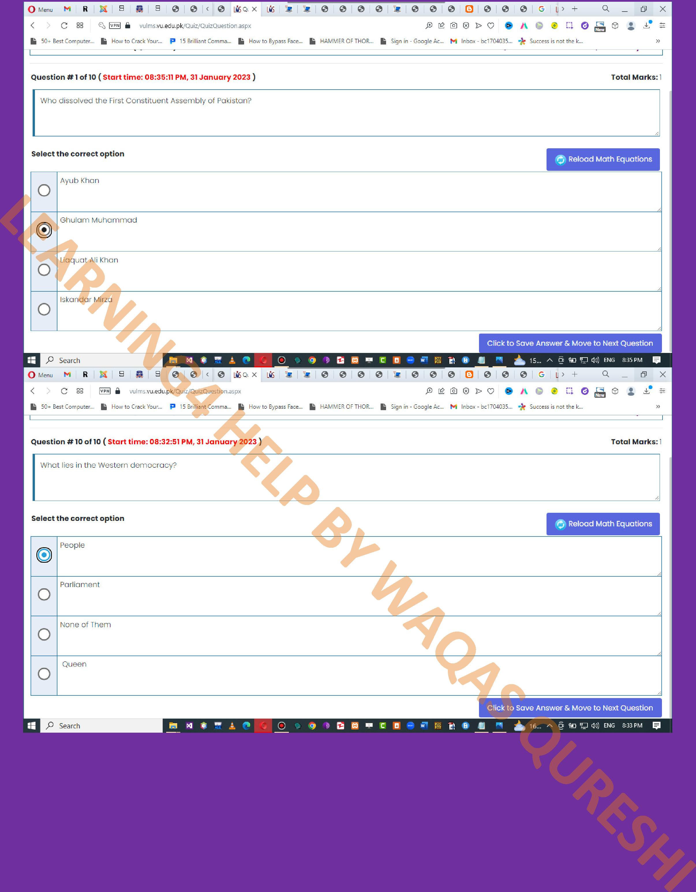
8

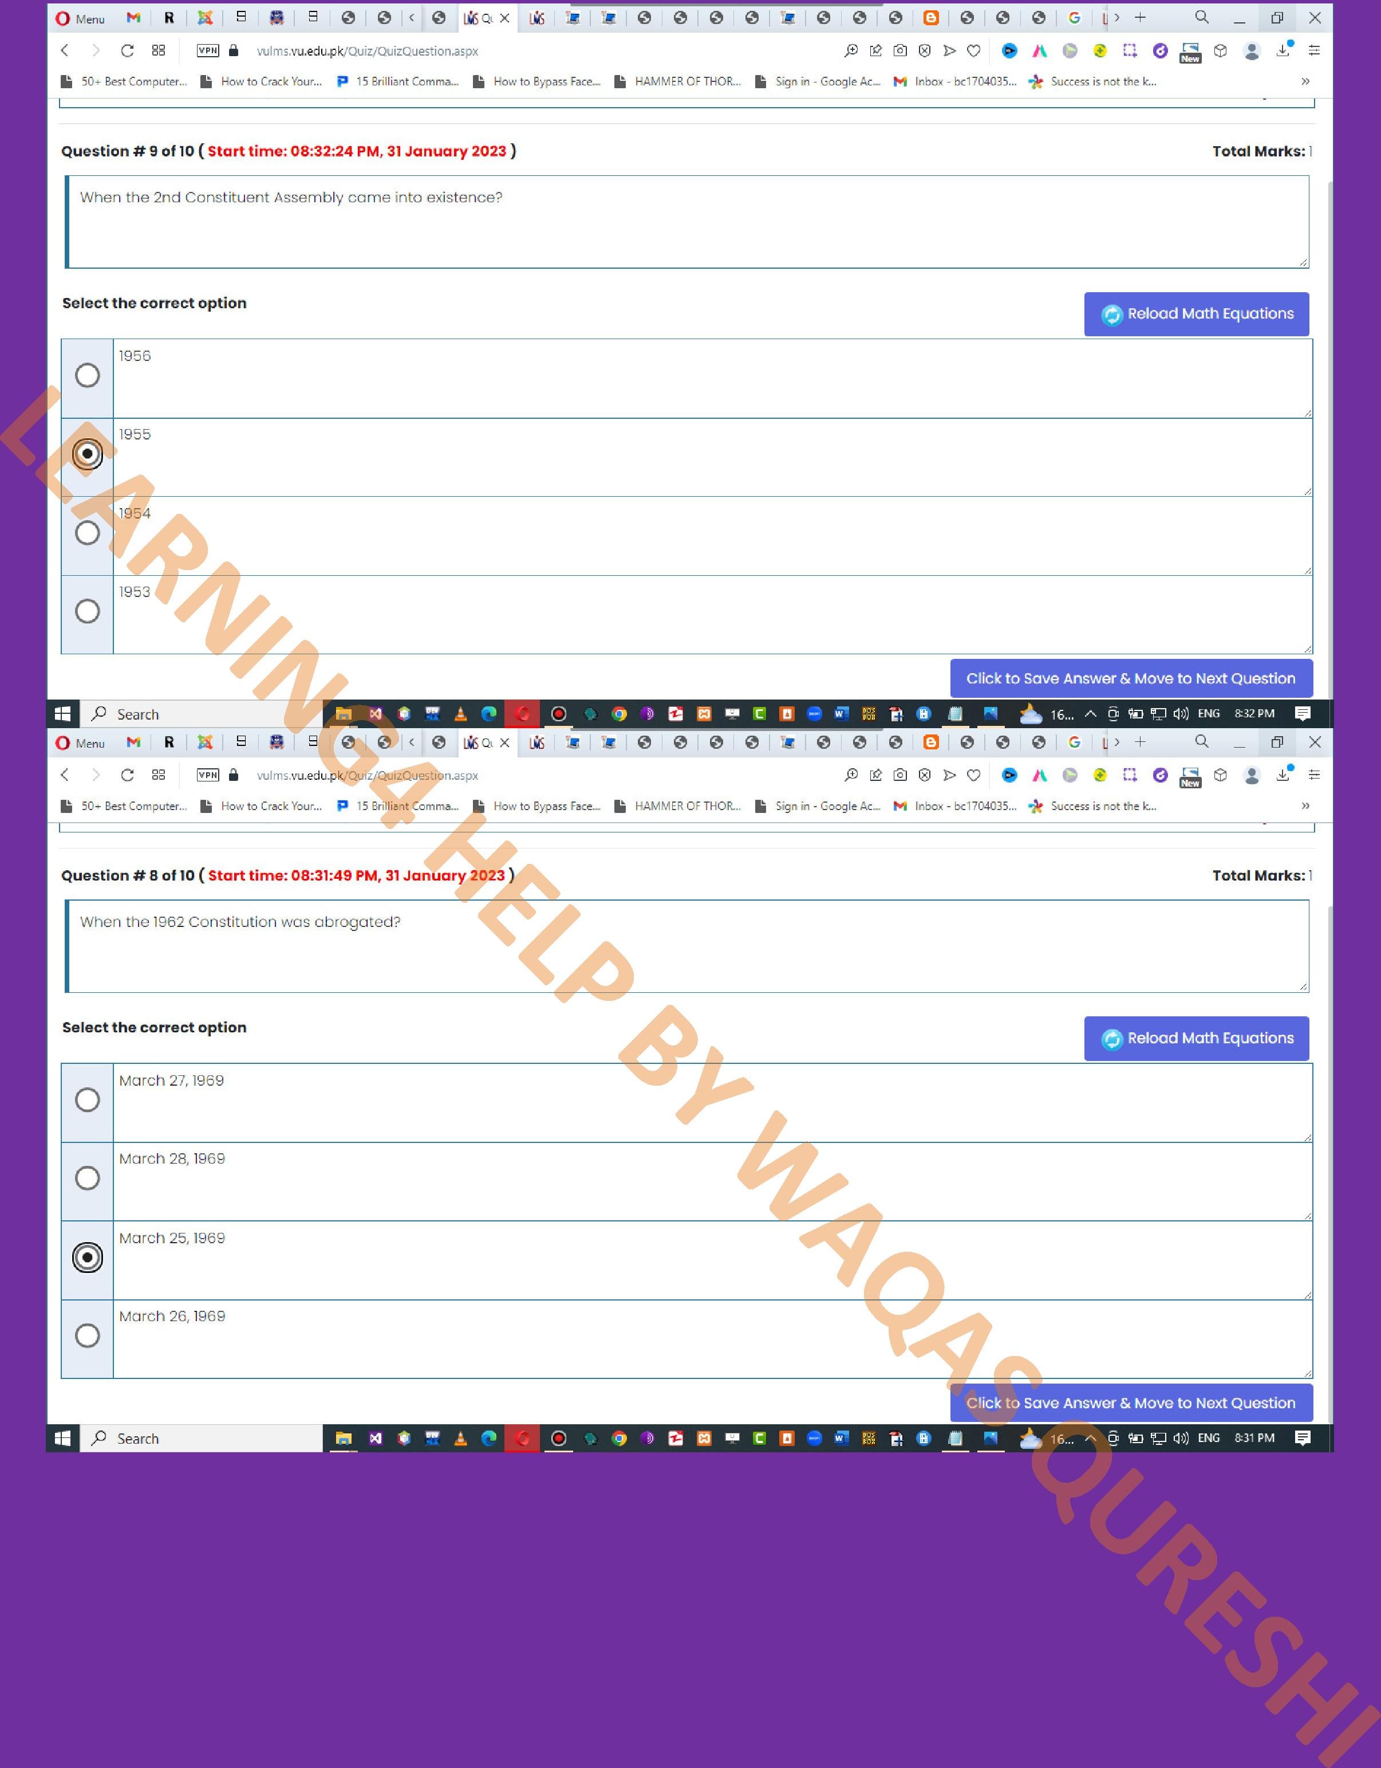
9

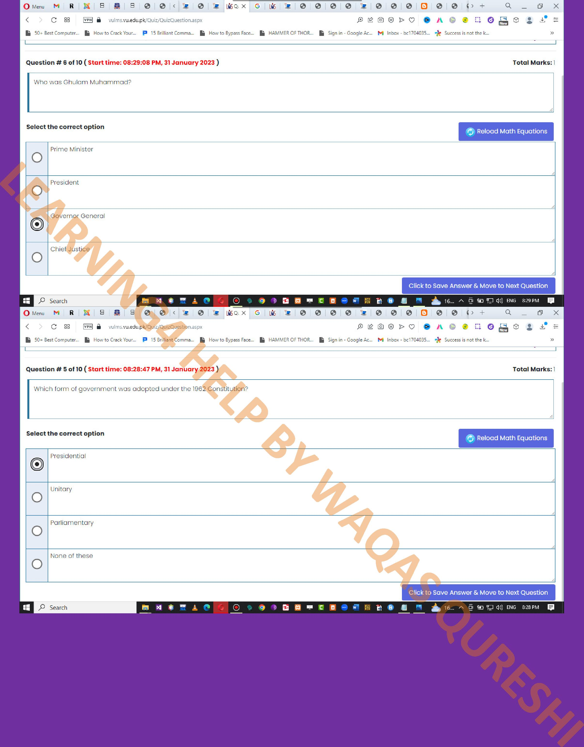
10

